Name___________________________ Per. _______

IPC Motion, Graphing, and Acceleration Exam Review

- What is the equation for calculating speed?

- Identify the difference between distance and displacement.

- Identify the different parts of the equation below.

a = _______ (v_{f} – v_{i})
v_{f} = ________ a = ---------
v_{i} = ________ t
t = ________

- Choose from the following options to describe what is happening in each graph below.
The object is …
- Travelling away from the starting point at a constant speed
- Returning to the starting point at a constant speed
- Not moving
- Accelerating
- Decelerating
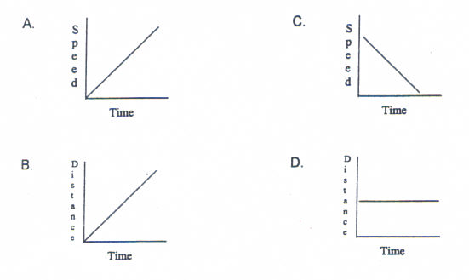
E. None of the Above
- Define acceleration.

- Correctly label each scenario below as either accelerating, stopped, or moving with a constant velocity.

- A plane speeding up on a runway. ________________________
- The Earth going around the sun. ________________________
- A car braking. ________________________
- A man walking 1.7 m/s in a straight line. ________________________
- A rock being thrown in the air. ________________________
- A car waiting at a red light. ________________________
- A car on cruise control going straight. ________________________
- A car on cruise control on a curve. ________________________

- Identify the difference between speed and velocity.

- If you walk 5 blocks South, then turn around and walk 2 blocks North, what is your total distance travelled? __________ What is your total displacement? _________

- If you walk 4 blocks East, then turn around and walk 4 blocks West, what is your total distance travelled? ___________ What is your total displacement? _________

- If you are driving at a constant speed of 800 m/h, how long will it take to travel a distance of 3,200 m?

- You’re driving at 65 mi/h when you come up on an accident and have to slam on your brakes. It takes you 7 seconds (0.002 hr) to come to a complete stop. Calculate your acceleration.

- Describe what is happening in each section of the Distance/time graph below.
B
E
D
C
A
- ___________ B.___________ C. ___________ D.___________ E.___________

