POGIL WS (pg.2) MOD Name: ______________________________
Motion Graphs
Date: _____________
Period: _____

- Consider the following graph of Cars A, B, and C:
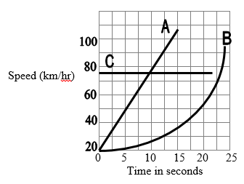
Identify each car below as A, B, or C:

- Which cars are accelerating? (There are 2!)

- Which car is driving at 75 km/hr at time zero seconds, and has an acceleration of 0 km/hr-s?

- Which cars are traveling the same speed at 9 seconds?

- Looking at the graphs below:

___ 1) Which graph(s) show constant speed?

___ 2) Which graph shows constant acceleration?

___ 3) Which graph shows no motion?

3. Both graphs below show Car A accelerating constantly at 32 m/s².

Graph 1: Speed (m/s) vs. Time (s) Graph 2: Distance (m) vs. Time (s)
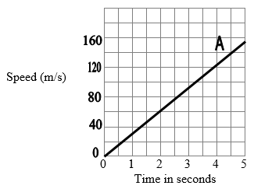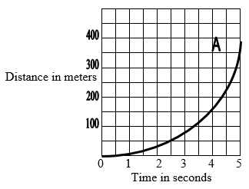

- Find the area under the line in Graph 1. Use the formula for the area of a triangle:

Area = (1/2) X base X height = (1/2) X 5 X 160 = ________meters

- How far did the car travel in 5 seconds according to Graph 2?

- Given your answer to parts a and b, fill in the blank:

If you have a graph of speed vs. time, the area under the graph is equal to the

__________________ the car traveled.

- Find the slope of the line in Graph 1.

Slope = $\frac{rise}{run}$ = $\frac{160}{5}$= _______ m/s²

How does the value for the slope relate to the acceleration of Car A (32 m/s²)?

