POGIL WS (pg.2) Name: ______________________________
Motion Graphs
Date: _____________
Period: _____

- Consider the following graph of Cars A, B, and C:
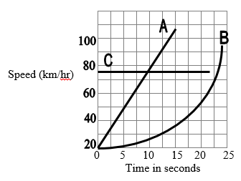

- Which car(s) is/are accelerating?

- Car D is driving at 60 km/hr at time zero seconds. The acceleration of Car D between 0 and 25 seconds is 0 km/hr-s. Draw the graph for Car D on the graph above.

- What is the average acceleration for Car A between the time of 0 and 5 seconds?

- Draw a graph for Car E on the graph above. Car E is traveling at 40 km/hr at time 0. The car’s average acceleration is 2 km/hr-s during the entire time interval of 0-25 seconds.

- Label each of the graphs with the following labels. You may use some more than once or not at all. (1) Constant Speed, (2) Constant Acceleration, (3) Not Moving, (4) Acceleration (not constant)
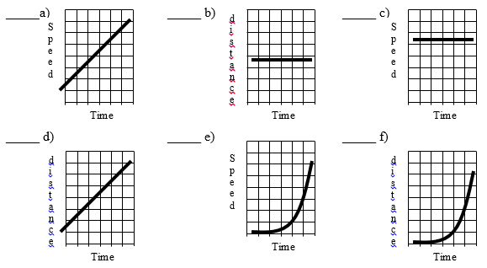

3. Consider the graph of speed vs. time for Car A as it accelerates constantly at 32 m/s².

Graph 1: Speed (m/s) vs. Time (s)
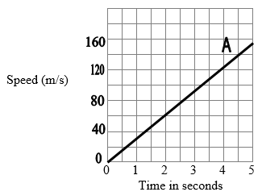

Graph 2: Distance (m) vs. Time (s) for the same car during the same time period.
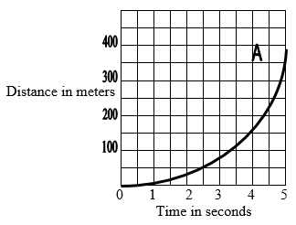

- Calculate the area under the line for Graph 1. Hint: this is like finding the area of a triangle using the formula area=1/2 base x height. The height is about 160 and the length of the base is about 5.

- Using Graph 2, find the distance the car traveled during the 5 second time span?

- Given your answer to parts a and b, fill in the blank: If you have a graph of speed vs. time, the area under the graph is equal to the __________________ the car traveled.

- Find the slope of the line in Graph 1. How does the value for the slope relate to the acceleration of Car A (as stated at the beginning of question 8)?

