Describing Waves MOD Name_________________

Need more help? Visit: Lesson 2 of the Waves chapter at The Physics Classroom:
http://www.physicsclassroom.com/Class/waves/u10l2a.html
http://www.physicsclassroom.com/Class/waves/u10l2b.html
http://www.physicsclassroom.com/Class/waves/u10l2c.html
http://www.physicsclassroom.com/Class/waves/u10l2d.html

- Label the graph below with the following letters:
  - Nodal line (aka your zero line)
  - Crest
  - Trough
  - Amplitude
  - Wavelength
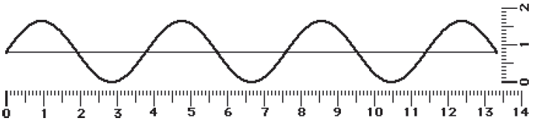

- Using the rulers seen in question #1, measure the wave’s wavelength and amplitude.

a. Wavelength =__________________ b. Amplitude = =__________________

Period or Frequency

- The number of cycles of a periodic wave per unit time is called the wave's ______________.

- The amount of time for a single periodic wave to occur is called the wave's _____________.

- A pendulum makes 40 vibrations in 20 seconds. Calculate its period? (T = time/cycle)

a. 0.5 sec b. 2 sec c. 800 sec

- A period of 5.0 seconds corresponds to a frequency of _____ Hz. (f = 1/T)

a. 0.2 b. 0.5 c. 0.02 d. 0.05 e. 0.002
- The period of a 261-Hertz sound wave is ________________. (T = 1/f)

a. 0.004 sec b. 130 sec c. 261 sec

- As the frequency of a wave increases, the period of the wave ___________.

a. decreases b. increases c. remains the same

- Mac and Tosh are resting on top of the water near the end of the pool when Mac creates a surface wave. The wave travels the length of the pool and back in 25 seconds. The pool is 25 meters long. Determine the speed of the wave. (v = speed in meters per second)

$speed=v= \frac{meters}{second}= \frac{length of pool \& BACK}{25 seconds}=$

- What is the frequency of the wave seen below? (Rearrange your speed equation: f = v/λ)

a. 0.33 Hz b. 2 Hz c. 18 Hz
